**Configuring the time zone and code page with Group Policy**

<https://dennisspan.com/configuring-the-time-zone-and-code-page-with-group-policy/>

Posted on [**October 7, 2017**](https://dennisspan.com/configuring-the-time-zone-and-code-page-with-group-policy/)

Configuring the time zone and code page with Group Policy enables the administrator to centrally manage these settings for a multitude of systems.

|  |
| --- |
| **Change Log** 18.01.2019: added the section [Redirecting the time zone of the local client in remote sessions](https://dennisspan.com/configuring-the-time-zone-and-code-page-with-group-policy/#RedirectTimeZone). |

|  |
| --- |
| **Table of Contents**   * + [Configuring the time zone using Group Policy](https://dennisspan.com/configuring-the-time-zone-and-code-page-with-group-policy/#ConfigTimeZone)     - [Configuring the time zone using PowerShell](https://dennisspan.com/configuring-the-time-zone-and-code-page-with-group-policy/#ConfigTimeZonePoSH)     - [Configuring the time zone using tzutil.exe](https://dennisspan.com/configuring-the-time-zone-and-code-page-with-group-policy/#ConfigTimeZoneTZUTIL)     - [Redirecting the time zone of the local client in remote sessions](https://dennisspan.com/configuring-the-time-zone-and-code-page-with-group-policy/#RedirectTimeZone)       * [Microsoft Remote Desktop Services](https://dennisspan.com/configuring-the-time-zone-and-code-page-with-group-policy/#RDS)       * [Citrix Virtual Apps and Desktops (CVAD) / XenDesktop](https://dennisspan.com/configuring-the-time-zone-and-code-page-with-group-policy/#CVAD)   + [Configuring the code page using Group Policy](https://dennisspan.com/configuring-the-time-zone-and-code-page-with-group-policy/#ConfigCodePage) |

**Configuring the time zone using Group Policy**

|  |
| --- |
| **Supported operating systems:** Windows 2003/XP and higher, up to and including Windows 10 and Windows Server 2016 (all versions and builds). **Supported deployment methods:** all, including direct (*bare-metal*) installations and image-based deployments using technologies such as Citrix Machine Creation Services (MCS) and Citrix Provisioning Services (PVS). |

This section deals with the configuration of the time zone settings. On a local machine, these are configured in the *Date & Time* settings. Time zone settings are system-specific and not configured per-user (although you can [redirect the local time zone](https://dennisspan.com/configuring-the-time-zone-and-code-page-with-group-policy/#RedirectTimeZone) in a remote session).

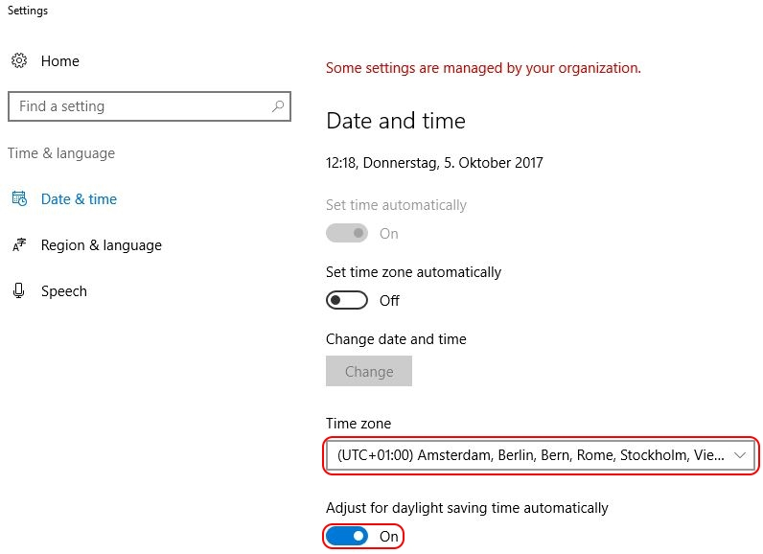

The time zone configuration is stored in the Windows registry in the **HKEY_LOCAL_MACHINE** hive. The exact registry key is:

**HKLM\SYSTEM\CurrentControlSet\Control\TimeZoneInformation**

The time zone settings consist of multiple values as seen in the screenshot below.

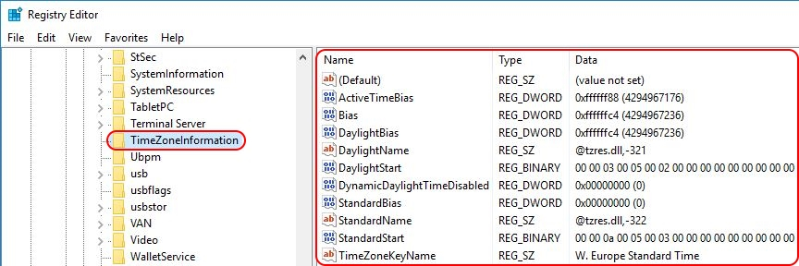

To find out the exact value for each of the ten registry entries, first set the time zone manually in the local *Date & Time* configuration. Afterwards, simply check the aforementioned registry values.

|  |
| --- |
| **Note:** all available time zones are also listed in the registry in the key *HKLM\SOFTWARE\Microsoft\Windows NT\CurrentVersion\Time Zones*. |

Open your Group Policy Management Console (GPMC.msc) and navigate to *Computer Configuration \ Preferences \ Windows Settings \ Registry*. Since we need to import multiple values, I suggest to use the registry wizard. With a right-mouse click on *Registry* select *New \ Registry Wizard*.Now that we have all the information we need, we can set the correct time zone for the local machine. The easiest way to accomplish this is by using a Group Policy Preference registry item. And no, unfortunately there is no native out-of-the-box group policy setting or preference to configure the time zone. This goes for all Windows operating systems.

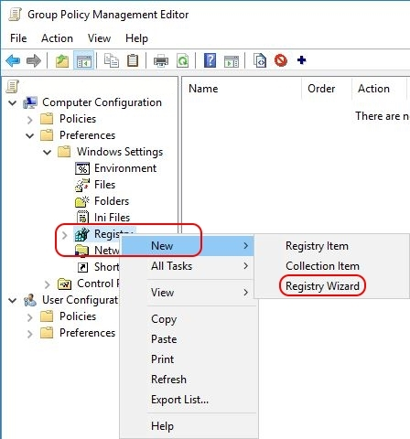

On the first page of the wizard, make sure that *Local Computer* is selected and click *Next*. On the second tab, the *Registry Browser*, navigate to the registry key *HKLM\SYSTEM\CurrentControlSet\Control\TimeZoneInformation*. Tick the box of each individual registry value (as shown in the image below). Use the scroll bar on the right to go down in the list. Unfortunately, there is no *Select All* option (@Microsoft: HINT!).

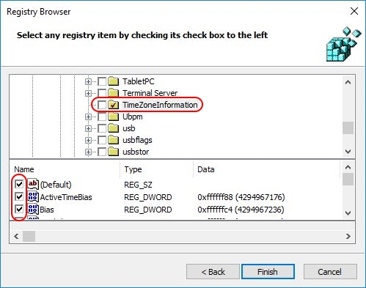

Click *Finish*. The registry values have been imported.

If you are unhappy with the organisation of the registry items, you can easily move the individual settings (in the blue box) to a new collection item.

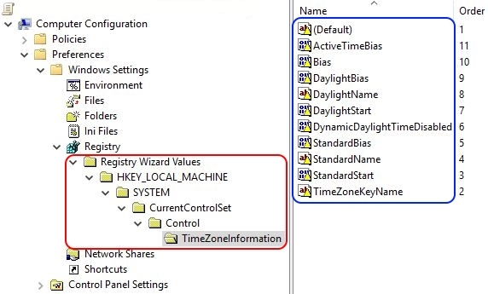

First, we need to create a new collection item (this is basically a folder). With a right-mouse click on *Registry* select *New \ Collection Item*. Enter a name for the collection item, for example *TimeZone*. Now you can move all individual registry items to this new collection item per drag-and-drop.

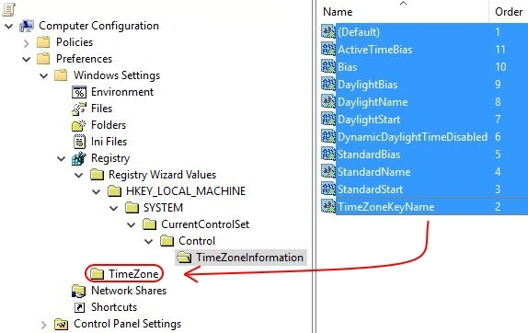

Afterwards, you can delete the collection item named *Registry Wizard Values* (all underlying folders are automatically deleted as well).

The registry item is now created and will be deployed to all machines to which the particular Group Policy applies.

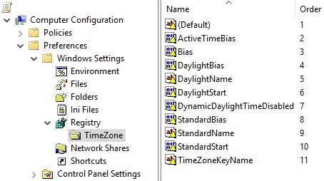

|  |
| --- |
| **Note:** by default, the value name is used as the name of the registry item (as is visible in the image above). It is possible to rename the registry item afterwards, but please be aware that whenever you make changes to the registry item, it's name will revert back to the value name. |

After configuring the time zone, restart the machine to allow the changes to take effect.

**Configuring the time zone using PowerShell**

|  |
| --- |
| **Supported operating systems:** Windows 7 / Windows Server 2008 R2 and higher, up to and including Windows 10 and Windows Server 2016 (all versions and builds), with PowerShell 5.1 installed (this is a requirement!). |

For those of you who want to include the configuration of the time zone in a PowerShell script, the cmdlet **Set-TimeZone** can be used. The basic command is as follows:

PowerShell



|  |  |
| --- | --- |
| 1 | Set-TimeZone -Id "W. Europe Standard Time" |

In case the time zone does not exist, an error is returned, which is great when using a *try/catch* statement. In the example below, I deliberately misspelled the time zone *W. Europe Standard Time* to force an error:

PowerShell



|  |  |
| --- | --- |
| 1  2  3  4  5  6  7 | [string]$TimeZone = "W. Europe Standard Timeeeeeeee"  try {     Set-TimeZone -Id $TimeZone     Write-Host "Success: the time zone $TimeZone has been set"  } Catch {     Write-Host "Error: the time zone $TimeZone does not exist!"  } |

The *Set-TimeZone* cmdlet is included in PowerShell 5.1 and, exceptionally, not restricted to the newest operating systems. This cmdlet also works on Windows 7 and Windows Server 2008 R2. PowerShell 5.1 is included in the [Windows Management Framework 5.1](https://www.microsoft.com/en-us/download/details.aspx?id=54616).

|  |
| --- |
| **Note:** running the *Set-TimeZone* PowerShell command as a startup script may end in error 5 "access denied". At least that is what happened when I tested it on a server running Windows Server 2016 version 1607. I do not know why this happened, especially since the group policy is executed by the local system account. |

One drawback of using this method (I can't believe I am about to say something *against* using PowerShell) is that the time zone will be hard-coded in the image. In case the time zone needs to be changed, you will have to do one (or more) of the following:

1. Update the master image.
2. Update each machine to which the master image was deployed. This only applies to direct (*bare-metal*) installations. In case you use deployment technologies such as Citrix Machine Creation Services (MCS) or Citrix Provisioning Services (PVS), you will have to update the master image and re-deploy it.
3. Use a Group Policy to change the time zone. This is the most flexible way to manage time zone settings on a multitude of machines.

**Configuring the time zone using *tzutil.exe***

|  |
| --- |
| **Supported operating systems:** Windows 2003/XP and higher, up to and including Windows 10 and Windows Server 2016 (all versions and builds). |

Besides the [PowerShell cmdlet](https://dennisspan.com/configuring-the-time-zone-and-code-page-with-group-policy/#ConfigTimeZonePoSH), Microsoft also offers the on-board utility **tzutil.exe** to configure the time zone. This tool has been part of the Windows operating system since Windows XP and Server 2003. Here is an example how to set the time zone to Western-Europe Standard Time:

**tzutil /s "W. Europe Standard Time"**

One drawback of using this method is that the time zone will be hard-coded in the image. Changing the time zone at a later time requires you to do one (or more) of the following:

1. Update the master image.
2. Update each machine to which the master image was deployed. This only applies to direct (*bare-metal*) installations. In case you use deployment technologies such as Citrix Machine Creation Services (MCS) or Citrix Provisioning Services (PVS), you will have to update the master image and re-deploy it.
3. Use a Group Policy to change the time zone. This is the most flexible way to manage time zone settings on a multitude of machines.

**Reference:** <https://technet.microsoft.com/en-us/library/hh875624(v=ws.11).aspx>